
MRN: | Date:
Surname: | Given Names:
Clinical Genetic Service | Address:
Dr Rani Sachdev & Dr Mary-Louise Freckmann

Dominic Ross
Level 1, Prichard Wing | Phone: (H) (W)
St George Hospital | (M)
Telephone: 9113 3635 | DOB: | Ward/Hospital:
Fax: 9113 3694
Relevant History | Medicare: exp: / /
Parity G P M T | Interpreter required Y / N
 | Language:
LMP / / | Reason for Referral
Cycle length days |  Late Maternal Age (>35 yrs at delivery)
Ultrasound this pregnancy Y / N |  Family history of
Date of ultrasound / /
Gestation at ultrasound |  Previous baby with congenital abnormality
weeks days
 |  Abnormal Ultrasound (bring ultrasound report)
Blood group:
Allergies:
 |  Consanguinity (partner should also attend)
Medications: |  Possible Teratogen exposure (notify us of details)
 |  Other (eg. recurrent miscarriage >3)
Provider No:
Print name: | Comment:
Address:
Phone:
Fax:
Signature:
 | Copy of report to:
Date:
Updated October 2015
Clinical Genetic Service | Patient Information
Level 1, Prichard Wing | - Bring your Antenatal card
St George Hospital
Enter the hospital via Short Street at Gate 9. Look for the building with the red awning. This is the Prichard Wing. | - Bring any ultrasound scan reports concerning this pregnancy
Telephone: 9113 3635 | - Bring any relevant blood test
Fax: 9113 3694 | results if you have them.

Appointment
Date: | Time:

Map of St George Hospital
Kensington St

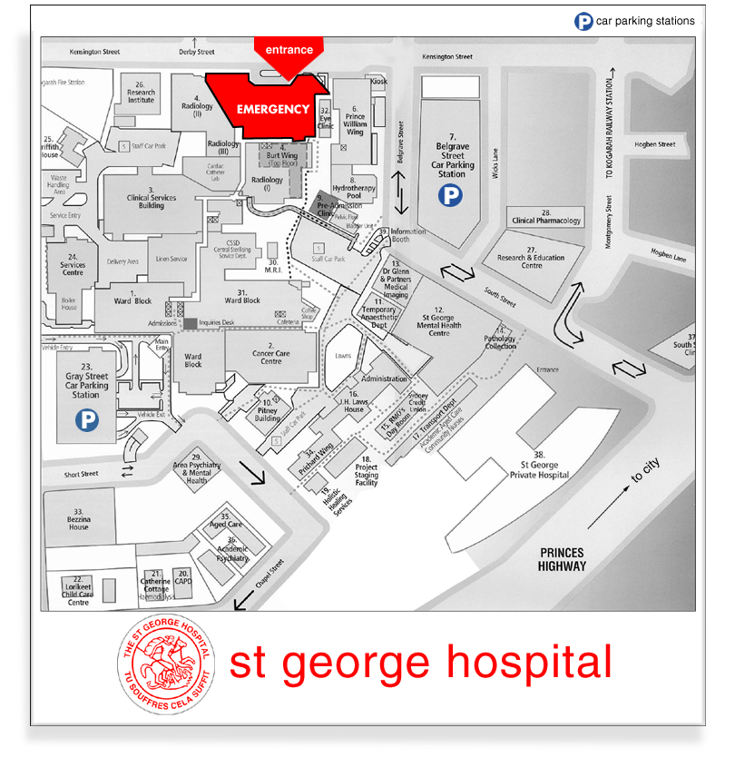

Gray Street
Clinical Genetic Service
Short St
Princes Hwy
Private Hospital
South St

