Patient Details  Surname:  Given Names:  MRN: DOB:  Phone Number:  Address: |  | Partner Details  Surname:  Given Names:  MRN: DOB:  Phone Number:  Address:
Medicare No:  
Interpreter required? Yes/No Language:
Relevant History  Parity: G P T M  LMP: EDC:  Current Gestation:  Date of Ultrasound:  Gestation at ultrasound:  Blood Group: (please provide written confirmation)  Hospital of Delivery:  Allergies:  Medications: | Reason for Referral   Increased risk of fetal chromosome abnormality (please include all relevant test results)   Abnormal Ultrasound (please send through ultrasound report)   Thalassemia (must include partners name & DOB, all screening results, ie. FBC, HbEPG and iron studies)   Family History   Other  Relevant detail:
Print Name:  Provider No:  Address:  Phone: Fax:  Completed By:  (print name)  Signature:  Copy of Report to: | Notes (internal use only)

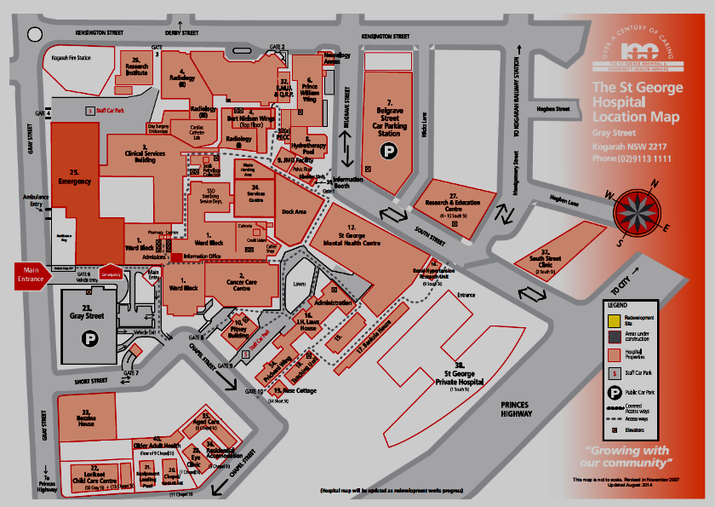
Women’s & Children’s Clinics & Clinical Genetics - Prichard Wing Level 1

